Clara Rockmore Theremin notes.
In my last drawings, posted on the Theremin world Tech. section, I forgot the couple trim capacitor that connects the two pitch oscillators. This is an essential part in this design. I have made some modifications: I have put in the timbre control that has been showed in the RCA inter-department Correspondence note: August 5 th, 1930, from engineer M. W. Will to T.S. Goldsborough. You will find these notes also on the Tech. section of the Theremin world. This switch will give you a normal Theremin sound, a brass, a wind wood or high flute sound. (see drawing) Each option need a correction for the pitch tuning, so switching while you are playing is not possible. Further is a good grounding needed, other-wise the low notes will grumble (perhaps a faulty uncoupled power supply ?).
I have put the capacitors and the trim capacitors (pitch, volume, couple caps. and trim caps.) on the top side of the chassis. This gives you the freedom to experiment and so get the oscillator frequencies, the range and sensitivity working well. (photo 3 and 4)
The couple trim affects the tone quality, the two potentiometers in the mixer tube (#24) makes it easy to tune the pitch, but this will also have an effect on the tone quality. The 50k pot. has the best sound at almost zero. (~1/4 position). The 25K pot can be used to make the pitch range greater or smaller in combination with the pitch tuning capacitor.
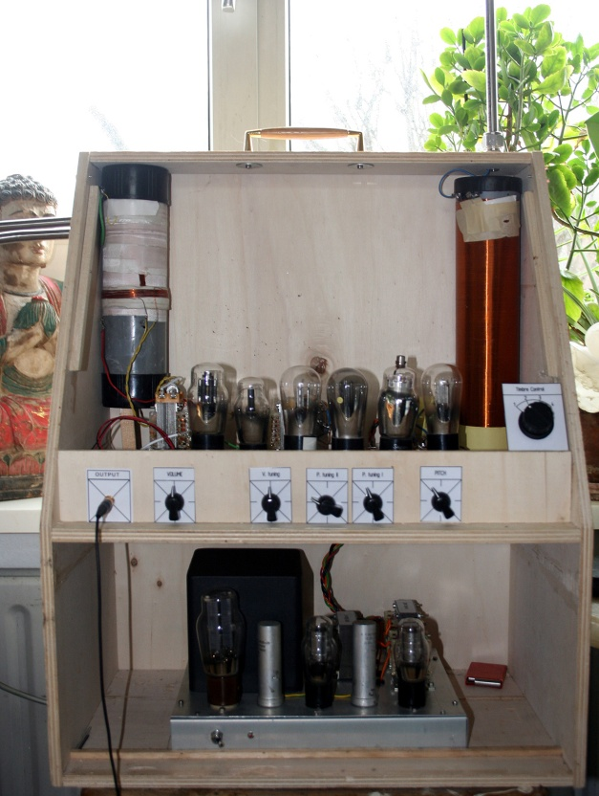
The output is on headphone level. I need a proper connector for the double triode (#53). This connector was in the Netherlands not available, So a made one myself (not a good quality, but working). If you have one in spare (7 contacts) please give me an email.
I’ll include pictures and the last drawings
Greetings from Theremin lover and builder,
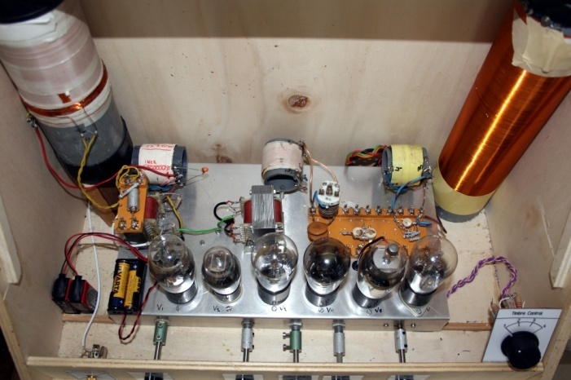
Adrian Bontenbal. a_bontenbal@live.nl
Photo 1: Top view: all oscillators on mounting boards. Photo 2: Clara Theremin front; from the left: output connector , volume and volume - tuning, Pitch tuning I-, Pitch-tuning II-, Pitch- and the Timbre control knobs. In the lower part you see the power supply.
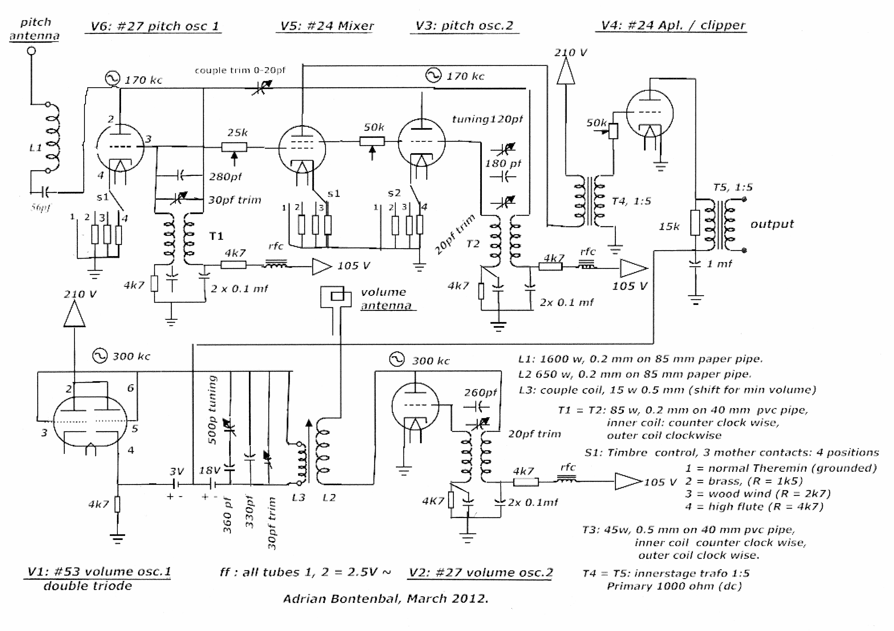
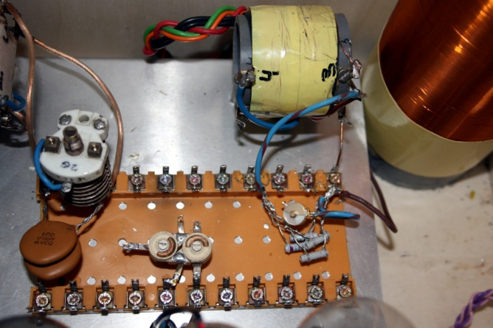
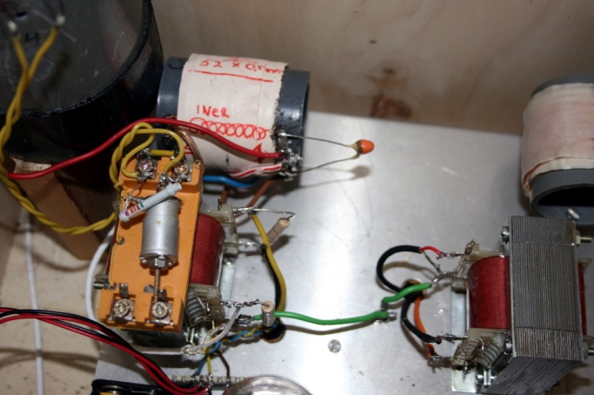
Photo 3: Volume oscillators on mounting board. Photo 4: Pitch oscillators on mounting board with the ceramic couple trim in the middle.

Clara Rockmore Theremin, with Timbre control switch: 3 mother contacts 4 positions. normal Theremin, brass, wood wind and high flute.

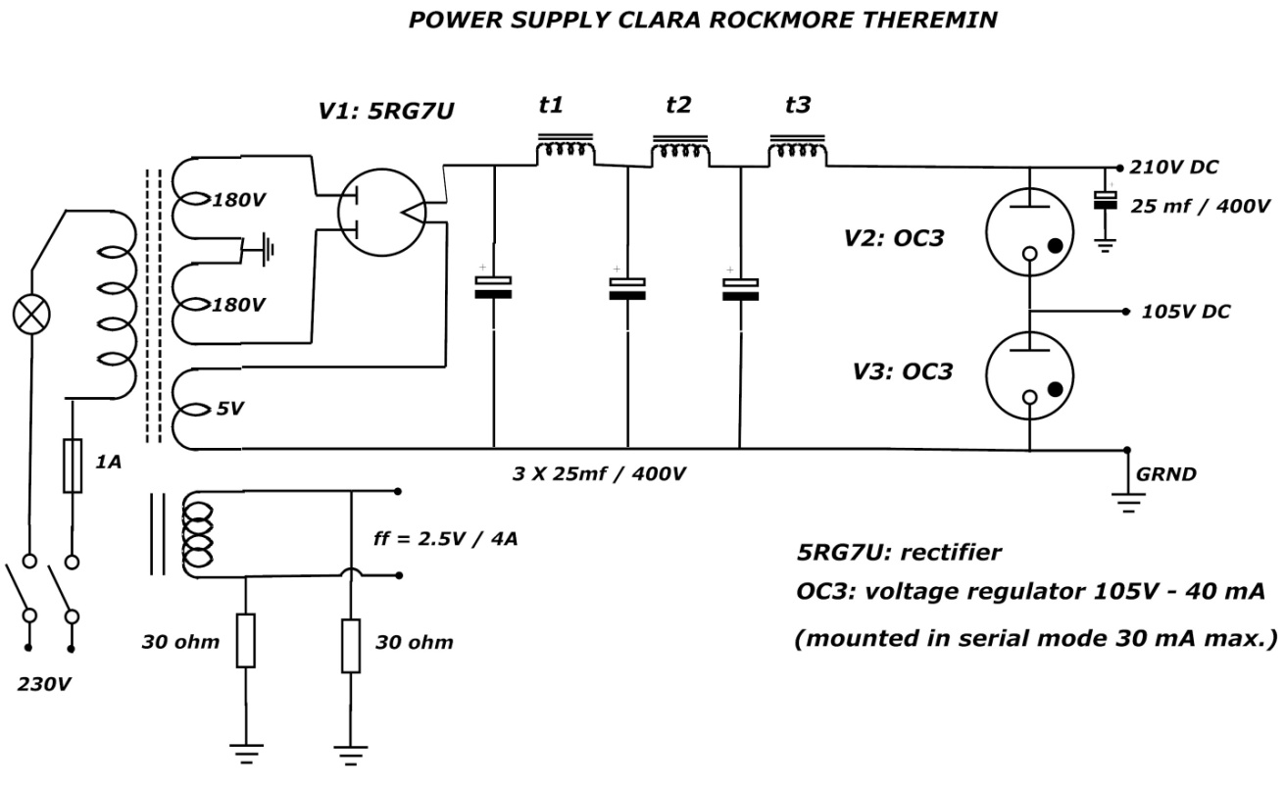
___________________________________________________

For practicing the theremin, a reference tone is very useful. This tone decoder circuit is an radio amateur schematic for telephone dialup signalizing. The frequency depends only on the 6.2k resistor and the 0.33 mF condenser. Replace the 6.2 k resistor for an 10k trim. pot and you can change the 440 Hz. to an other tone frequency. For example the old 330Hz A
I connected the input of this circuit to the output of T4 (the 50K pot.).
The circuit is working with a 5 to 9 volt power. I use an 9V battery for supply in this circuit, with a switch to put it on when I need it.

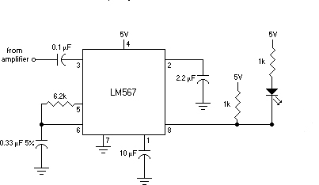

Tone decoder for 440 HZ (standard A)

Greetings, Adrian Bontenbal

