THEREMIN

Main Board

All resistors are 1/2W 5% carbon

Pot 33K is A-law, 1W (wounded)

Capacitors
550 pF : (1%, 250V, ceramic) associate 330 + 220
420 pF (id) 68 + 150
1 uF 10%, 160V DC, paper
10uF : 10%, 250V, chimical polarised
22uF : 10%, 40V, id
150 pF : air-variable
150 pF : air-adjust

tranformers
antic models used in old battery-receivers (1/3 and 1/5 ratio) : LF, iron core

electronic tubes
E424, E415, E438 : LF antic triodes (4V heating) can be replaced with (12AU7 ?)
AF2 : HF variable transconductance pentode, used as mixer (6DA6 ?)
C443 : final power pentode (6BQ5 ?)
B406 (osc) : replaced with 12AU7
B406 (var resistor) : replaced with 3A5 (the 2 triodes in parallel connection)

Coils (the most important !)
T1895 (beat oscillators transformer) :
On a 43 mm diameter linen tube (impregnated), 85 turns 25/100mm (insulated wire) (tube length :50 mm) wound start : grid, wound end : polarisation (4700 ohm, 1uF)
Then, insulation with adhesive tape (7/10 mm thick)
Finally, 85 turns, in opposite wound, like 1st winding. Wound start : plate, wound end : +HV
Characteristics measurement : the 2 sections in serie connection, L=1.3mH and Cr=50 pF

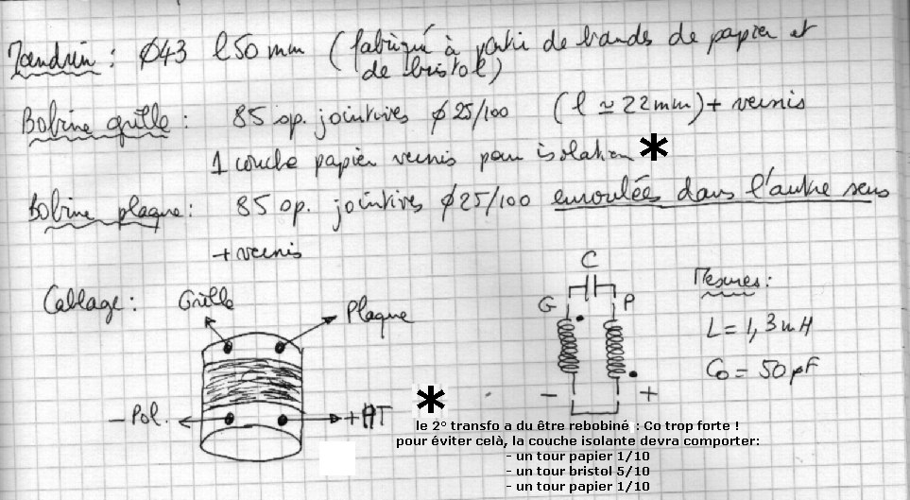

T1905 (vol oscillator) :
Same tube, but : 37 turns 6/10 mm insulated wire (grid winding)
Insulation : 48 mm diameter linen tube (stopped with little pieces of linen or plastic)
Plate winding : 37 turns, in opposite wound.
Connections : identical at T1895
Measurement : L=235uH, Cr=40 pF

T1899 (pitch control coil)
One solenoid coil and inside, one concentrated coil. These coils is in serie connection
Solenoid :
Linen tube, 83 mm diameter, length : 305 mm
Wound : start at the top (> pitch antenna) ; 1500 turns 16/100 mm (wound length : 270mm)
Measurement : L=46mH, Cr=3.9pF, R=320 ohm
Concentrated coil :
Plastique tube, 9.5mm diameter, length 21mm + core
Wound : 1400 turns 16/100
Measurement : 8.8mH (core off), … 28 mH (core at central position) / Cr=50 pF/ R=45 ohms
(refer drawing for concentrated coil positionning in solenoid coil and for connection)
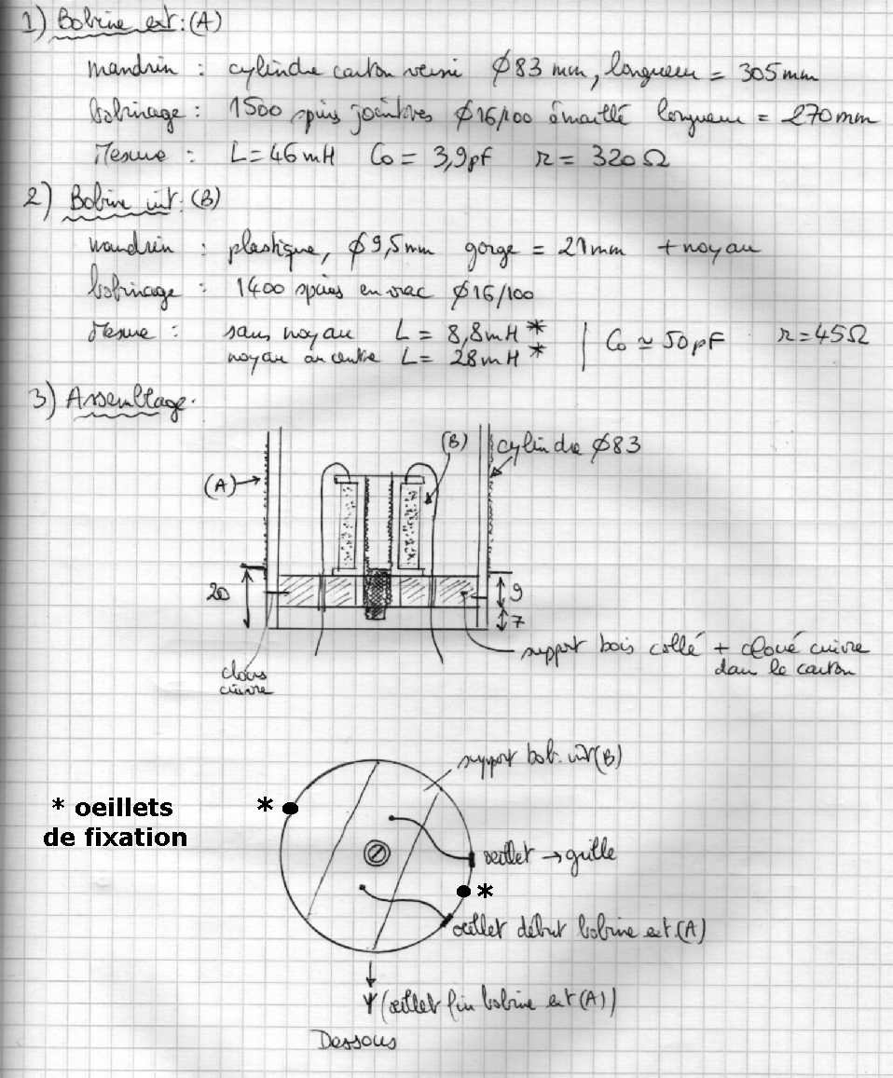

T1907 (volume control coil)
Solenoid :
Linen tube, 83 mm diameter, length : 170 mm
Start wounding at the top (> volume antenna) ; 750 turns 16/100 (135 mm length)
Measurement :L=19 mH, Cr=6pF, R=160 ohm)
Pick-up coil :
Linen tube, 94 mm diameter, length : 20 mm
25 turns, 6/10 mm (16mm length)
when you slide this pick-up coil on the solenoid coil, you can adjust min volume. (start position : at the bottom) : refer drawing

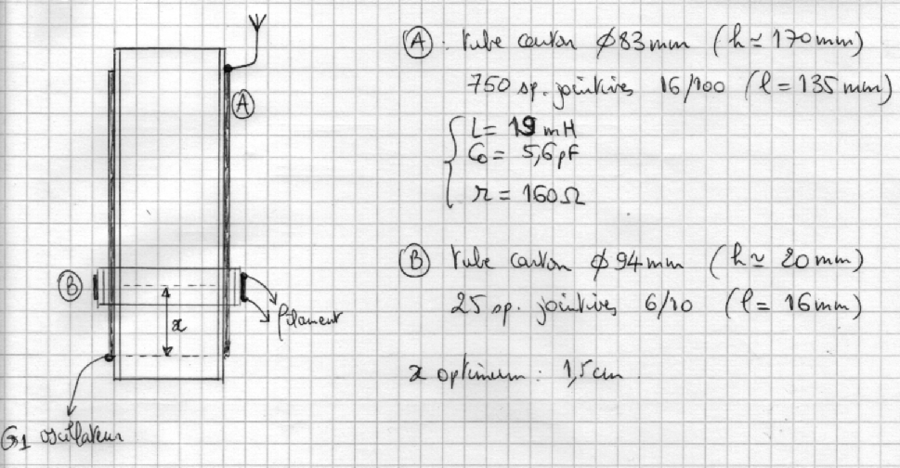

Power Unit

Nothing particular,
Power transformer (40 ..50 VA), for you 120 V primary voltage !
Instead 4V, use 6.3V for heating !
Replace fixed polarisation by automatic polarisation in 6BQ5 cathod return ! (and connect 6BQ5 cathod and 12AU7 volume oscillator together)
Use loud-speaker transformer in respect of 6BQ5 impedance !

See schematics

